Use Case Diagram: Use case diagram shows different ways in which a user might interact with a system. Use case shows the functionality of your system. Actor will be using your system.

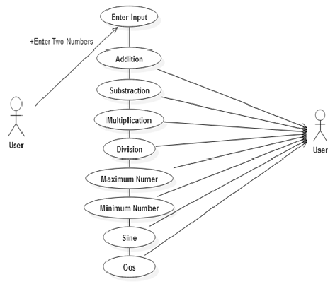

Class Diagram: DefVar: Define variable. + Public, - Private access

